Antes que nada, si lees esto Consor, hay comandos coloque una sola vez, porque hay muchos que es escribir literalmente lo mismo pero cambiar las ips, por eso algunas veces subí solo lo de una sucursal.

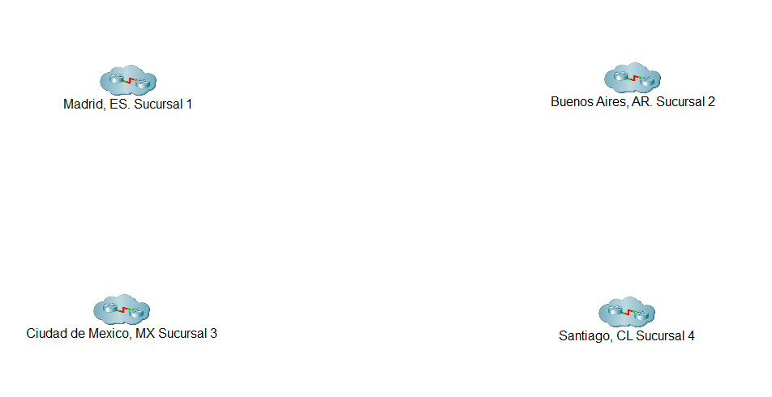

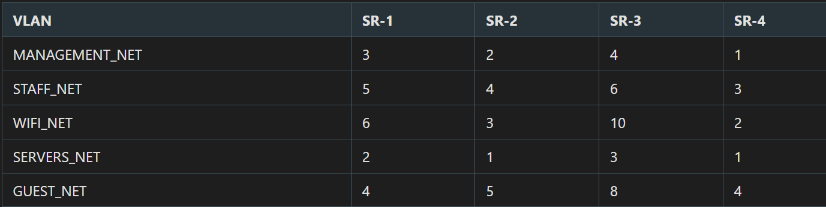

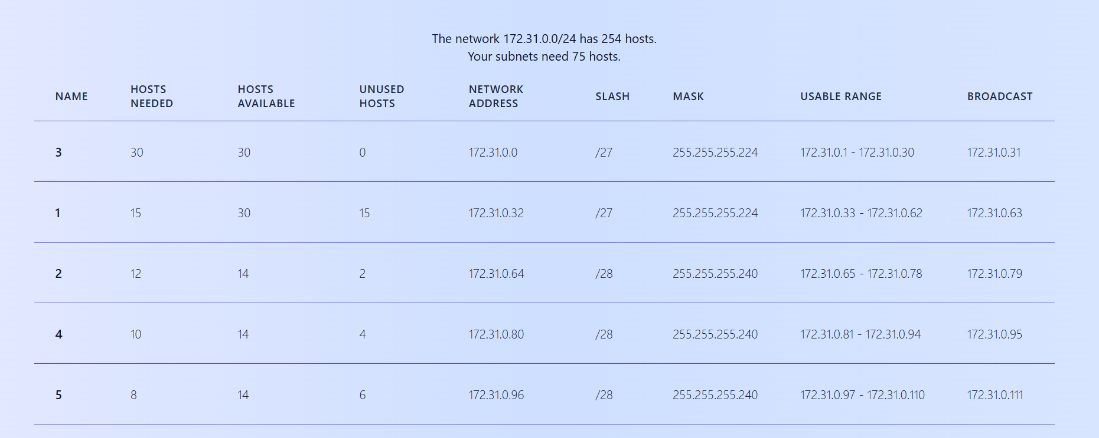

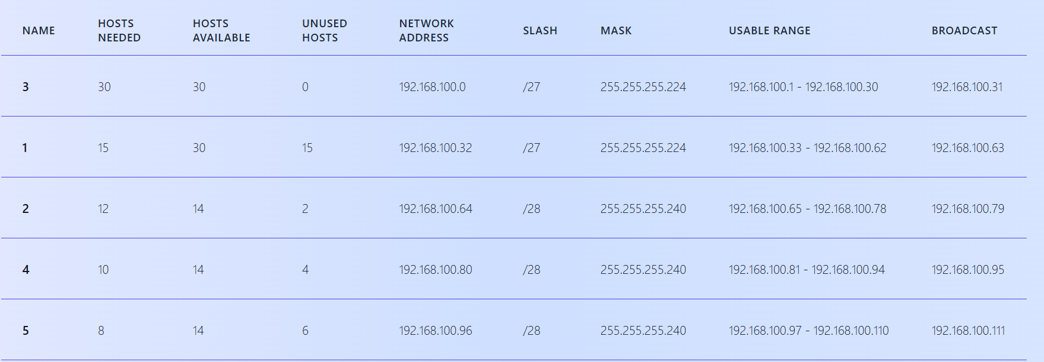

enable
configure terminal
vlan 10
name MANAGEMENT_NET
exit
vlan 20
name STAFF_NET
exit
vlan 30
name WIFI_NET
exit
vlan 40
name SERVERS_NET
exit
vlan 50
name GUEST_NET
end
write memory
interface range fastEthernet 0/23-24
switchport access vlan 40
no shutdown
exit
interface fastEthernet 0/1
switchport access vlan 30
no shutdown
exit
configure terminal
! 1. Configurar la interfaz física (Puerta de enlace)
interface GigabitEthernet0/0/0
no ip address
no shutdown
exit
! 2. Configuración de Subinterfaces para cada VLAN
interface gigabitEthernet 0/0/0.10
encapsulation dot1Q 10
ip address 172.31.0.1 255.255.255.224
no shutdown
exit
! 3. Configuración de Subinterfaces para STAFF_NET
interface gigabitEthernet 0/0/0.20
encapsulation dot1Q 20
ip address 172.31.0.33 255.255.255.224
no shutdown
exit
! 4. Configuración de Subinterfaces para WIFI_NET (Corrección de máscara y dirección)
interface gigabitEthernet 0/0/0.30
encapsulation dot1Q 30
ip address 172.31.0.65 255.255.255.240
no shutdown
exit
configure terminal
! Excluir direcciones de Gateway y estáticas (ej. servidores)
ip dhcp excluded-address 172.31.0.1 172.31.0.3
ip dhcp excluded-address 172.31.0.33 172.31.0.35
ip dhcp excluded-address 172.31.0.65 172.31.0.67
ip dhcp excluded-address 172.31.0.81 172.31.0.83
ip dhcp excluded-address 172.31.0.97 172.31.0.99
! Pool MANAGEMENT_NET (VLAN 10)
ip dhcp pool MANAGEMENT_NET
network 172.31.0.0 255.255.255.224
default-router 172.31.0.1
dns-server 8.8.8.8
exit
! Pool STAFF_NET (VLAN 20)
ip dhcp pool STAFF_NET
network 172.31.0.32 255.255.255.224
default-router 172.31.0.33
dns-server 8.8.8.8
exit
! Pool WIFI_NET (VLAN 30)
ip dhcp pool WIFI_NET
network 172.31.0.64 255.255.255.240
default-router 172.31.0.65
dns-server 8.8.8.8
exit
! Pool SERVERS_NET (VLAN 40)
ip dhcp pool SERVERS_NET
network 172.31.0.80 255.255.255.240
default-router 172.31.0.81
dns-server 8.8.8.8
exit
! Pool GUEST_NET (VLAN 50)
ip dhcp pool GUEST_NET
network 172.31.0.96 255.255.255.240
default-router 172.31.0.97
dns-server 8.8.8.8
exit
configure terminal
! Excluir direcciones (debe coincidir con la red 192.168.100.x)
ip dhcp excluded-address 192.168.100.1 192.168.100.3
ip dhcp excluded-address 192.168.100.33 192.168.100.35
ip dhcp excluded-address 192.168.100.65 192.168.100.67
ip dhcp excluded-address 192.168.100.81 192.168.100.83
ip dhcp excluded-address 192.168.100.97 192.168.100.99
! Pool MANAGEMENT_NET
ip dhcp POOL MANAGEMENT_NET
dns-server 8.8.8.8
network 192.168.100.0 255.255.255.224
default-router 192.168.100.1
exit
! Pool STAFF_NET
ip dhcp POol STAFF_NET
dns-server 8.8.8.8
network 192.168.100.32 255.255.255.224
default-router 192.168.100.33
exit
! Pool WIFI_NET
ip dhcp pool WIFI_NET
dns-server 8.8.8.8
network 192.168.100.64 255.255.255.240
default-router 192.168.100.65
exit
! Pool SERVERS_NET
ip dhcp pool SERVERS_NET
dns-server 8.8.8.8
network 192.168.100.80 255.255.255.240
default-router 192.168.100.81
exit
! Pool GUEST_NET
ip dhcp pool GUEST_NET
network 192.168.100.96 255.255.255.240
default-router 192.168.100.97
exit
end
configure terminal
interface GigabitEthernet0/0/0
no ip address
no shutdown
exit
!
interface GigabitEthernet0/0/0.10
encapsulation dot1Q 10
ip address 203.0.113.1 255.255.255.224
no shutdown
exit
!
interface GigabitEthernet0/0/0.20
encapsulation dot1Q 20
ip address 203.0.113.33 255.255.255.224
no shutdown
exit
!
interface GigabitEthernet0/0/0.30
encapsulation dot1Q 30
ip address 203.0.113.65 255.255.255.224
no shutdown
exit
!
interface GigabitEthernet0/0/0.40
encapsulation dot1Q 40
ip address 203.0.113.97 255.255.255.224
no shutdown
exit
!
interface GigabitEthernet0/0/0.50
encapsulation dot1Q 50
ip address 203.0.113.129 255.255.255.224
no shutdown
exit
### Configuración SR-1
configure terminal
router rip
version 2
no auto-summary
network 172.31.0.0
network 11.0.0.0
network 44.0.0.0
### Configuración SR-2
configure terminal
router rip
version 2
no auto-summary
network 203.0.113.0
network 11.0.0.0
network 44.0.0.0
### Configuración SR-3
configure terminal
router rip
version 2
no auto-summary
network 192.168.100.0
network 11.0.0.0
network 44.0.0.0
### Configuración SR-4
configure terminal
router rip
version 2
no auto-summary
network 198.51.100.0
network 11.0.0.0
! Las reglas de la ACL 198 (Source 198.51.100.x)
access-list 198 permit ip 198.51.100.96 0.0.0.31 any
access-list 198 permit ip any 172.31.0.96 0.0.0.31
access-list 198 permit ip any 203.0.113.96 0.0.0.31
access-list 198 permit ip any 192.168.100.80 0.0.0.15
! Permisos "Igual con Igual" hacia Madrid (172.31.0.x)
access-list 198 permit ip 198.51.100.0 0.0.0.31 172.31.0.0 0.0.0.31
access-list 198 permit ip 198.51.100.32 0.0.0.31 172.31.0.32 0.0.0.31
access-list 198 permit ip 198.51.100.64 0.0.0.31 172.31.0.64 0.0.0.31
access-list 198 permit ip 198.51.100.128 0.0.0.31 172.31.0.128 0.0.0.31
! Permisos "Igual con Igual" hacia Buenos Aires (203.0.113.x)
access-list 198 permit ip 198.51.100.0 0.0.0.31 203.0.113.0 0.0.0.31
access-list 198 permit ip 198.51.100.32 0.0.0.31 203.0.113.32 0.0.0.31
access-list 198 permit ip 198.51.100.64 0.0.0.31 203.0.113.64 0.0.0.31
access-list 198 permit ip 198.51.100.128 0.0.0.31 203.0.113.128 0.0.0.31
! Permisos "Igual con Igual" hacia CDMX (192.168.100.x)
access-list 198 permit ip 198.51.100.0 0.0.0.31 192.168.100.0 0.0.0.31
access-list 198 permit ip 198.51.100.32 0.0.0.31 192.168.100.32 0.0.0.31
access-list 198 permit ip 198.51.100.64 0.0.0.31 192.168.100.64 0.0.0.15
access-list 198 permit ip 198.51.100.128 0.0.0.31 192.168.100.96 0.0.0.15
! Aplicación de la ACL 198 de salida
interface Serial0/1/0
ip access-group 198 out
exit
interface Serial0/1/1
ip access-group 198 out
exit
interface Gigabit0/0/2
ip access-group 198 out
exit
do write
crypto isakmp policy 10
authentication pre-share
hash sha
encryption aes 256
group 2
lifetime 86400
exit
crypto isakmp key toor address 11.0.0.2 (IP del destino, 'toor' es la clave pre-compartida)
crypto ipsec transform-set TSET esp-aes esp-sha-hmac
! ACL para definir el tráfico que se va a encriptar (Tráfico interesante)
access-list 101 permit ip 192.168.1.0 0.0.0.255 192.168.11.0 0.0.0.255
access-list 101 permit ip 192.168.1.0 0.0.0.255 192.168.12.0 0.0.0.255
crypto map CMAP 10 ipsec-isakmp
set peer 12.0.0.2 (IP de la interfaz serial pública del router destino)
match address 101 (El número de la ACL de tráfico interesante)
set transform-set TSET
exit
interface serial 0/1/0
crypto map CMAP
do write
exit
Router2
interface Serial0/0/0
ip address 192.0.2.2 255.255.255.252
no shutdown
interface Tunnel0
ip address 10.10.10.2 255.255.255.252 (IP del túnel)
tunnel source Serial0/0/0 o IP (Interfaz o IP de salida pública)
tunnel destination 192.0.2.1 (IP de la interfaz del lado destino)
! Enrutamiento sobre el túnel
ip route 192.168.1.0 255.255.255.0 10.10.10.1
o sino con rip:
router rip
network 10.10.10.0 (en rip agregamos la red del túnel)

